B. In-Depth Explanation & Analysis
1. The Greenhouse Effect: A Natural Necessity Students often think the "Greenhouse Effect" is bad. It's actually vital! Without naturally occurring CO2 and water vapor trapping terrestrial radiation, Earth's average temperature would be a freezing -18°C instead of the comfortable +15°C we have.
- The Problem: "Global Warming" is the enhanced greenhouse effect due to excess human-added CO2.
- Think of this as: A blanket. You need one to stay warm at night (natural greenhouse effect). But if you add five more blankets, you'll overheat (global warming).
2. Normal Lapse Rate vs. Temperature Inversion
- Normal Lapse Rate: Usually, temperature decreases as you go up in the Troposphere (about 6.5°C per km) because you are moving away from the heat source (the ground).
- Inversion of Temperature: sometimes, this reverses. A layer of cool air gets trapped below warm air. This often happens on calm, cold winter nights in valleys. It causes fog and traps pollutants (smog) close to the ground.
3. Heat Budget Imagine Earth receives 100 units of energy from the sun.
- ~35 units are reflected back immediately by clouds/ice (called Albedo).
- ~65 units are absorbed (14 by atmosphere, 51 by earth's surface).
- Eventually, all 65 units must be radiated back to space to maintain balance.

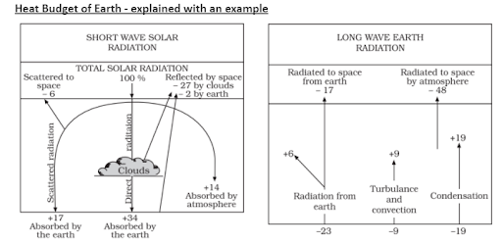
Mentor’s insight:
- The role of carbon dioxide in the greenhouse effect and the protection of the ozone layer are important topics.
- Remember the composition and the importance of various gases in the atmosphere. Along with the importance of different atmospheric layers (for example: mesosphere is the coldest layer of the atmosphere, also called the meteor layer)
- Earth’s axis makes an angle of 66.5, affecting the amount of insolation received at different latitudes.
- Long-wave radiation is what gets trapped by greenhouse gases.

